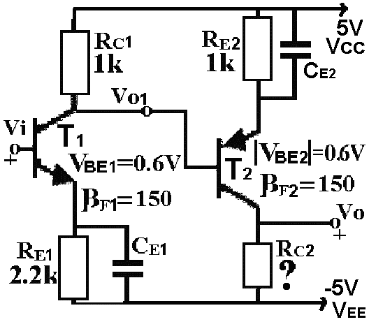
Figure-1a

Q1- β=150 and ⏐V_{BE}⏐≅0.6V are given for the transistors
in Figure-1a (V_{T}≅25mV)
a) Vo=0V is required for Vi=0V. Find I_{C1}, I_{C2} and R_{C2}. (10Points)
(Transistors are in the active mode)

b)Figure-1b shows simplified ac model of the circuit.
Find ri, Gv and ro.(10Points)

c) An ac voltage source Vg that has a serial resistance Rg of
1k, is connected to the input of the circuit and a load resistance
Figure-1b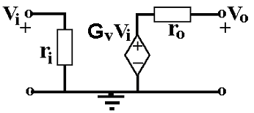
R_{Y} of 2.2k to the output. Find ac gain vo/vg. (10Points)

Solution:
a)
Two ways given in Figure-S11 can be used for obtaining the
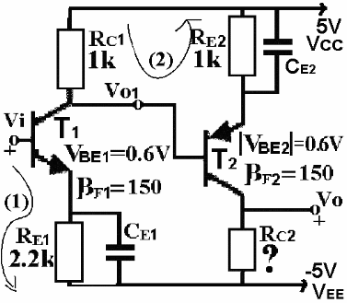
Figure-S11
transistor collector currents.
From (1)
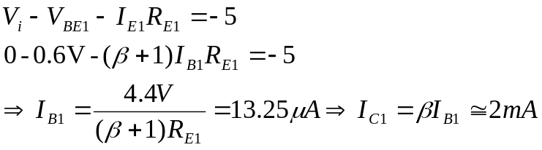
From(2)
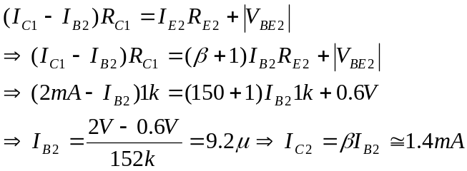

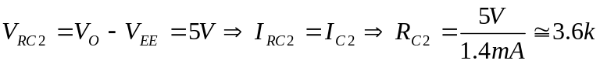
b) ri: ac input resistance of the circuit ro: ac output resistance of the circuit
G_{v}: ac gain (vo/vi) of the circuit without a load.
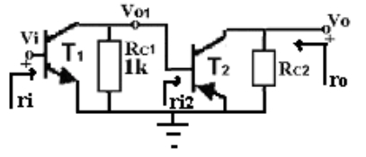
Figure-S12

Ac case of the circuit is given in-Figure-S12.
Thus:
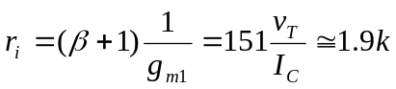
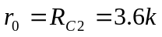

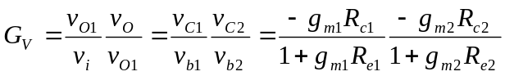

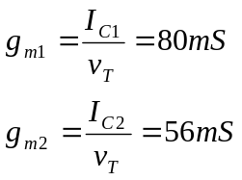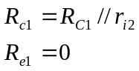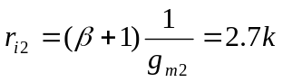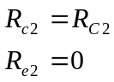
c)
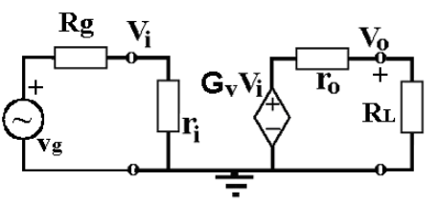
Figure-S13
From Figure-S13: 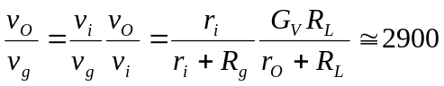

*************************************************************************************
Q2-For the MOS transistors in Figure-2a
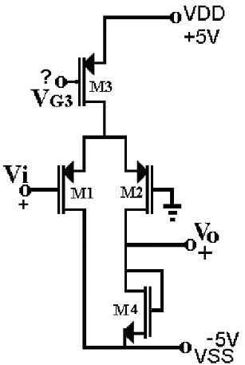
Figure-2a
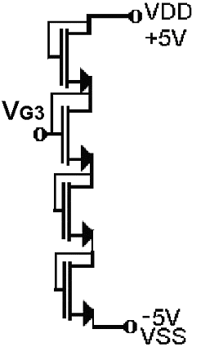
Figure-2b
β₁=β₂=10mA/V², β₃=1.8mA/V², β₄=0.2mA/V²,
V_{TH1}=V_{TH2}= V_{TH3}= -1V and V_{TH4}=1V are given.
(All transistors are in saturation mode.)

a) Find I_{D1} and I_{D2} for Vi=0V. (10Points)
(Note that the circuit given in Figure-2b is used in order to
get V_{G3} and all transistors in Figure-2b have the same properties.)

b) Find ac gain of the circuit (vo/vi). (10Points)
Solution:
In Figure-2b, the transistors are the same.
On the other hand, one sees from the configuration that
their drain currents are the same, too. And their gates and drains are short-circuit (V_{GD}=0V<V_{TH}=1V, so they are in saturation mode). Therefore, their gate-source voltages should be the same.
(Everything is the same!)
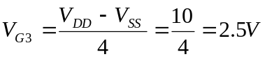

b)
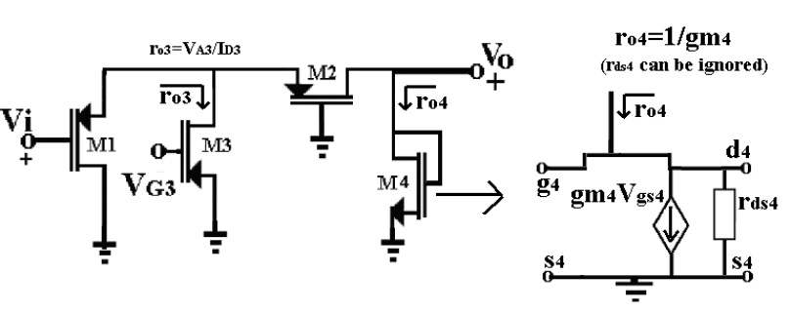
Figure-S21 ac case of the circuit.

